**Department of Engineering Technology**

**Foundation University Islamabad**

**School of Science and Technolog**

Object Oriented Programming Lab

**NAME: Muhammad Anas**

**ROLL NO: 072**

**lab 1**

**topic : Introduction to ADT and Arrays**

**objective :** **Displaying Array Elements**

|  |  |  |  |  |  |
| --- | --- | --- | --- | --- | --- |
| **Performance** | | | **Lab Report** | | |
| **Description** | **Total Marks** | **Marks Obtained** | **Description** | **Total Marks** | **Marks**  **Obtained** |
| **Problem Understanding** | **5** |  | **Code Writing** | **5** |  |
| **Communication** | **5** |  |  |  |  |
| **Total Marks obtained** | | |  | | |

**Remarks (if any): ………………………………….**

**Name & Signature of faculty: …………………………………**

Introduction to ADT and Arrays

* Write a program to store 10 marks in an array and show 1st and 2nd highest marks on screen.

1. #include<iostream>
2. using namespace std;
3. int main()
4. {
5. 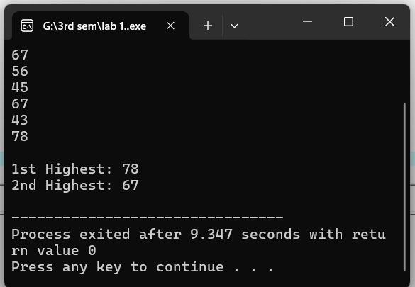 int marks[10], first, second;
6. cout<<"Enter 10 marks: ";
7. for(int i=0; i<10; i++)
8. cin>>marks[i];
9. first = second = marks[0];
10. for(int i=0; i<10; i++)
11. {
12. if(marks[i] > first)
13. {
14. second = first;
15. first = marks[i];
16. }
17. else if(marks[i] > second && marks[i] != first)
18. {
19. second = marks[i];
20. }
21. }
22. cout<<"\n1st Highest: "<<first;
23. cout<<"\n2nd Highest: "<<second<<endl;
24. return 0;

}

* . Write a program to take size of an array from user and store elements in an array.Take any element from user and search either entered number exist in an array or not using binary search.

1. #include<iostream>
2. 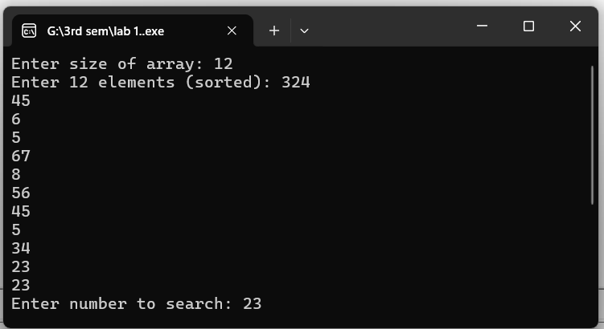using namespace std;
3. int main()
4. {
5. int n, num, mid, low=0, high;
6. cout<<"Enter size of array: ";
7. cin>>n;
8. int arr[n];
9. cout<<"Enter "<<n<<" elements (sorted): ";
10. for(int i=0; i<n; i++)
11. cin>>arr[i];
12. cout<<"Enter number to search: ";
13. cin>>num;
14. high = n-1;
15. bool found = false;
16. 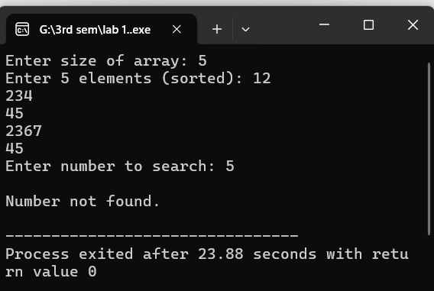 while(low <= high)
17. {
18. mid = (low + high)/2;
19. if(arr[mid] == num)
20. {
21. found = true;
22. break;
23. }
24. else if(arr[mid] < num)
25. low = mid+1;
26. else
27. high = mid-1;
28. }
29. if(found)
30. cout<<"\nNumber found at index "<<mid<<endl;
31. else
32. cout<<"\nNumber not found."<<endl;
33. return 0;

* Write a program to take size of an array from user and store elements in an array. Take

any element from user and search either entered number exist in an array or not using

1. binary search.  
   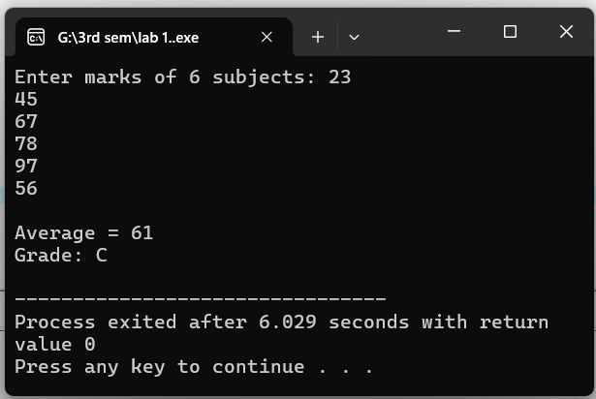#include<iostream>
2. using namespace std;
3. int main()
4. {
5. int marks[6], sum=0;
6. float avg;
7. cout<<"Enter marks of 6 subjects: ";
8. for(int i=0; i<6; i++)
9. {
10. cin>>marks[i];
11. sum += marks[i];
12. }
13. avg = sum/6.0;
14. cout<<"\nAverage = "<<avg;
15. if(avg > 90) cout<<"\nGrade: A+";
16. else if(avg > 80) cout<<"\nGrade: A";
17. else if(avg > 70) cout<<"\nGrade: B";
18. else if(avg > 60) cout<<"\nGrade: C";
19. else if(avg > 50) cout<<"\nGrade: D";
20. else cout<<"\nGrade: F";
21. cout<<endl;

return 0PAGE BORDERQq

}